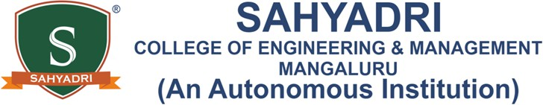

Activity Report

|  |  |  |
| --- | --- | --- |
| **ACTIVITY 1** | | |
| **Start Date: 5-2-2025** | | **Start Time of the Day: 8 am** |
| **End Date: 15-2-2025** | | **End Time of the Day: 6 pm** |
| **Date: 8-2-2025** | | **Day: Saturday** |
| Place: | Kanyana Bantwala | |
| Activity Title: | Visit to Bharath seva ashram | |
| Theme: | Developing and managing efficient garbage disposable system | |
| Organizing Department: | Department of Electronics and Communication Engineering | |
| Mode | Offline | |
| Activity Objective: | To clean the old age home, promote hygiene, and educate residents and staff on proper waste segregation for a healthier and cleaner living environment. | |
| Outcome/Benefit for Participants: | Cleaning the old age home created a healthier and more comfortable environment for the residents. By removing waste and organizing the area, we helped improve hygiene and reduce the risk of infections. The staff and residents learned about proper waste segregation and how it helps maintain cleanliness in the long run. A cleaner space also promotes better mental and physical well-being for the elderly. They appreciated our efforts and the positive impact it had on their surroundings. This initiative not only improved their living conditions but also encouraged them to continue following better waste management practices. | |
| Event Details/ Highlights: | Today, we visited an old age home as part of our garbage disposal system | |

|  |  |
| --- | --- |
|  | project. Our main goal was to clean the area and create a healthier environment for the residents. We noticed that waste was not properly segregated, which made the surroundings untidy and unhygienic.  We worked together to clean the space, remove waste, and organize the area. While doing this, we also educated the residents and staff about the importance of waste segregation. We explained how separating biodegradable and non- biodegradable waste helps keep the surroundings clean, prevents diseases, and improves overall hygiene.  The elderly residents and staff appreciated our efforts and the knowledge we shared. They understood how small changes in waste disposal habits could make a big difference in maintaining cleanliness. Many of them showed interest in continuing proper waste management practices to keep their home clean and safe.  This activity not only improved the living conditions of the old age home but also spread awareness about responsible waste management. It was a meaningful experience, and we felt happy knowing that our efforts made a positive impact on the residents’ lives. |
| Number of participants: | Old age home residents |
| Feedback of Participants: | The residents and staff appreciated our efforts in cleaning and teaching waste segregation. The knowledge we shared helped them maintain a cleaner and healthier living environment.  PRAMILA(8050861614) |

|  |  |
| --- | --- |
| Photographs: |  |

